**# A Bus Booking System**

Where Bus services can,

* register their new operator(Operator Id, Operator name, Address, Phone, Email)

here Operator Id, Operator name and Phone are mandatory fields.

* add their new Buses(Bus Id, type, capacity, Fare, Operator Id)

here all the fields are mandatory.

Operator Id must be same as filled while registering the Operator.

* set new Route(Route Id, start, stop), and

here all the fields are mandatory.

* schedule new Run(Bus Id, Running Date, seats Available, Route Id)

here all the fields are mandatory.

Bus Id must be same as filled while registering the Bus.

Route Id must be same as filled while registering the Route.

And users can,

* search for trips/buses : (to, from, date)

* by clicking on show bus it gives out the list of all the buses

* select one of the listed buses

* if there is no bus found for particular trip it will show error message: no buses found!

* enter booking details of passenger(name, gender, no. of seats, mobile number, age) and confirm booking

here name, no. of seats and mobile number are mandatory fields.

if any of these fields remains empty it will show error messages.

if required no. of seats is greater than available seats it will deliver a message: seats not available

if phone number is not of length 10 it will deliver a message: invalid mobile number

* now click on book seat, it will pop up a total amount confirmation message box

* after confirmation of amount it will show you your ticket.

* search for their tickets : using their registered mobile number

* if multiple tickets are registered with same mobile number you can view all tickets using next arrow (>)

* if no trip is registered with this mobile number it will show error.

--------------------------------------------------------------------------------------------------------------------------------------

#### **To run the app**

On terminal : python3 'app.py'

Directly : click on file named ‘app.py’

--------------------------------------------------------------------------------------------------------------------------------------

**#### Sample details that are needed to be filled**

**\*while registering bus**

new Operator -> 23456 , Kamla Travels, Guna, 1234567890, kamla@gmail.com

new Bus -> 3344, AC 3x2, 50, 550, 23456

new Route -> 9876, guna, indore

new Run -> 3344, 03-12-2023, 40, 789

* **while booking**

To : indore

From : guna

Date : 03-12-2023

\***below has shown sample photos of app:**

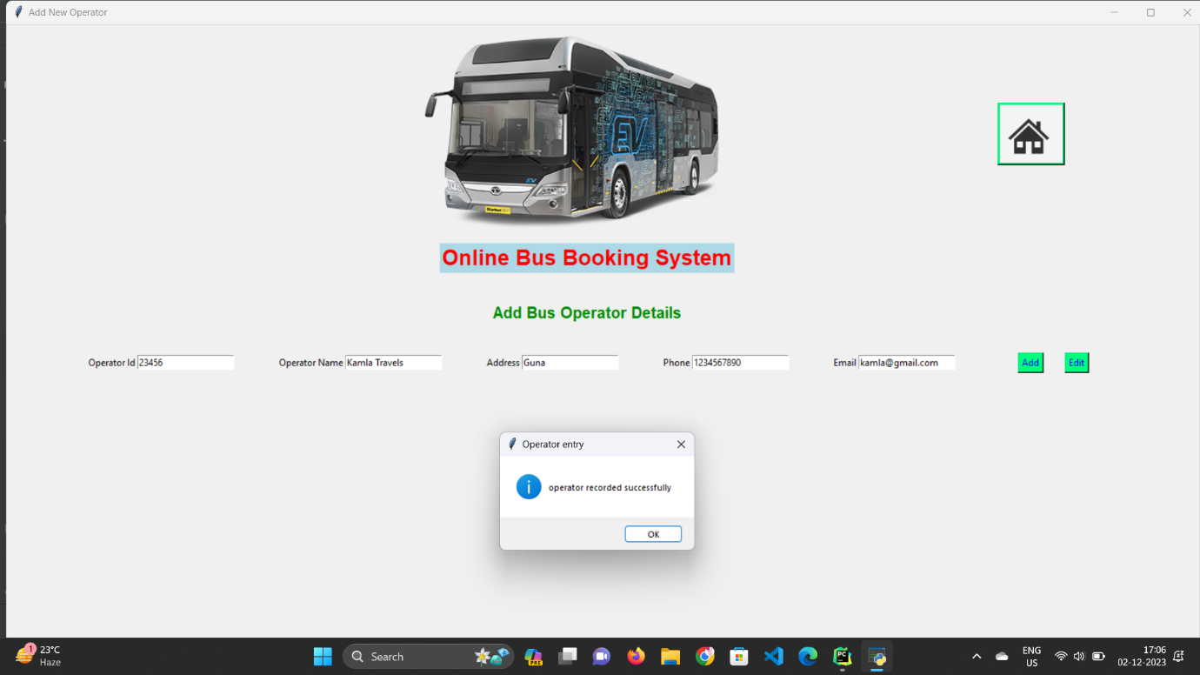

# registering new Bus Operator with following details (23456 , Kamla Travels, Guna, 1234567890, kamla@gmail.com)

# registering new Bus with following details(3344, AC 3x2, 50, 550, 23456)

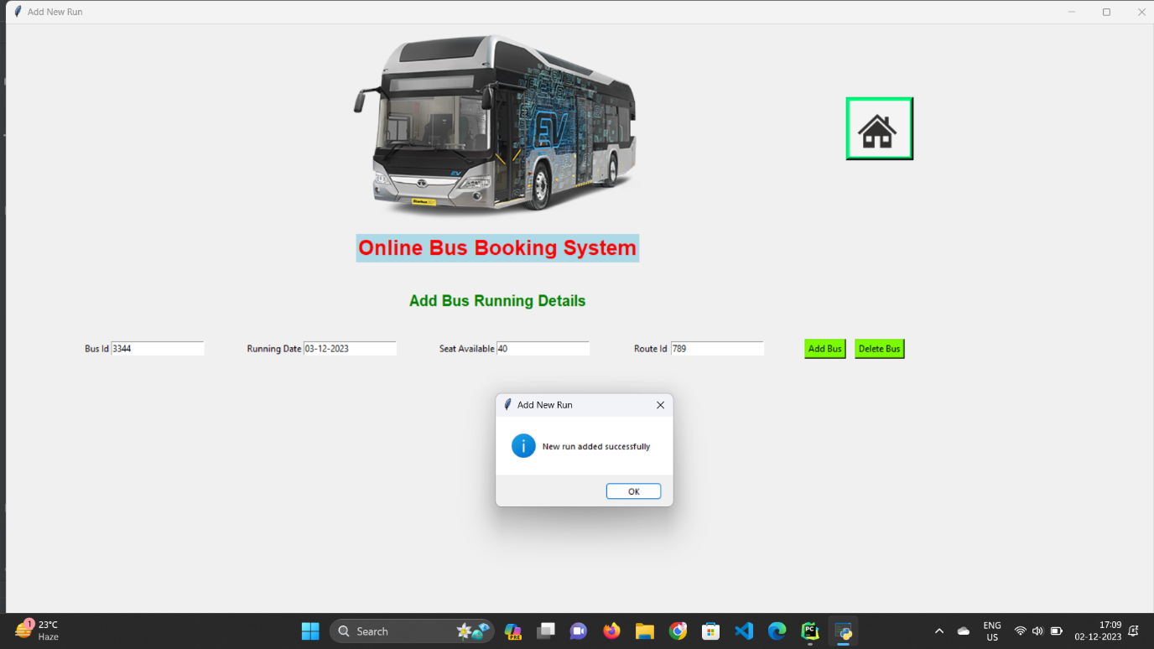# registering new Route with following details(9876, guna, indore)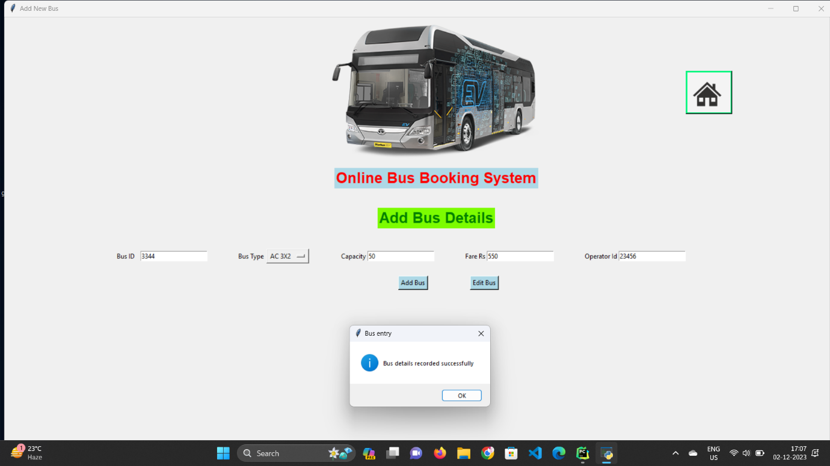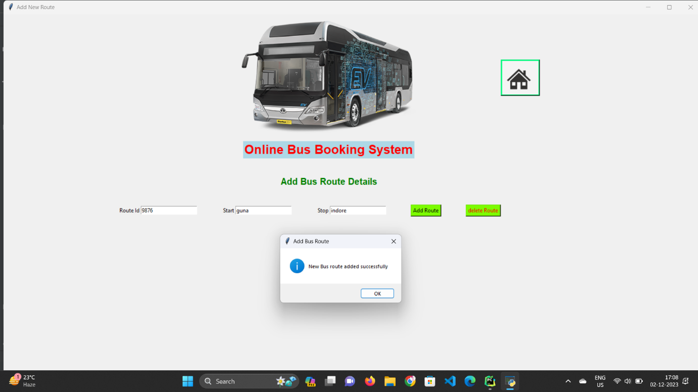

# registering new Run with following details(3344, 03-12-2023, 40, 789)

# filled trip details (indore, guna, 03-12-2023)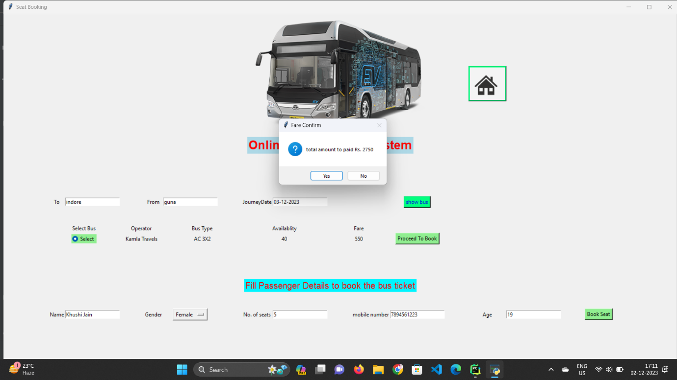

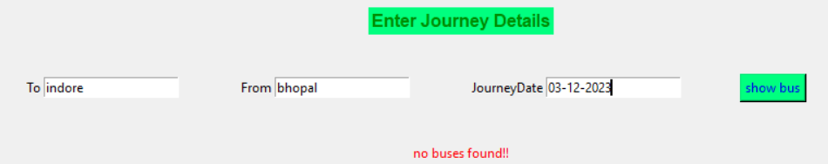

# displays error when no bus is found on following route on respective date

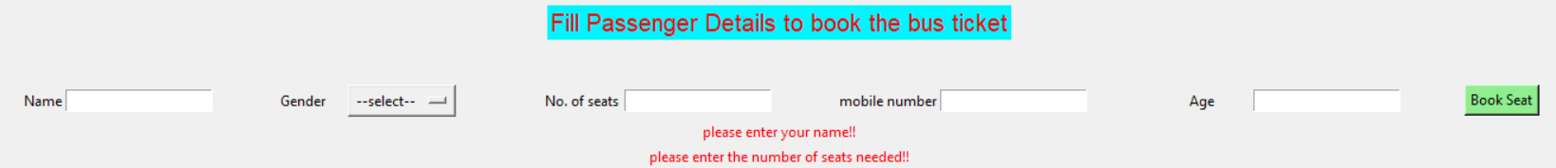

# displays error when you book seat without filling name, no. of seats and mobile number

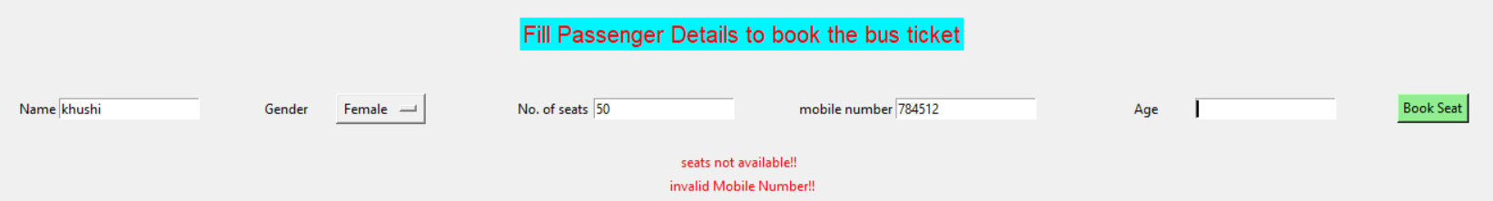

# displays error when seat limit exceeds or mobile number is not of length 10

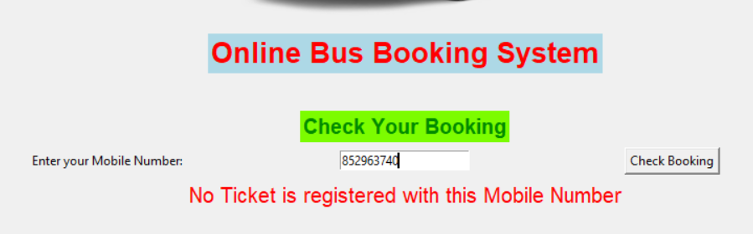

# displays error when no trip is registered with this mobile number

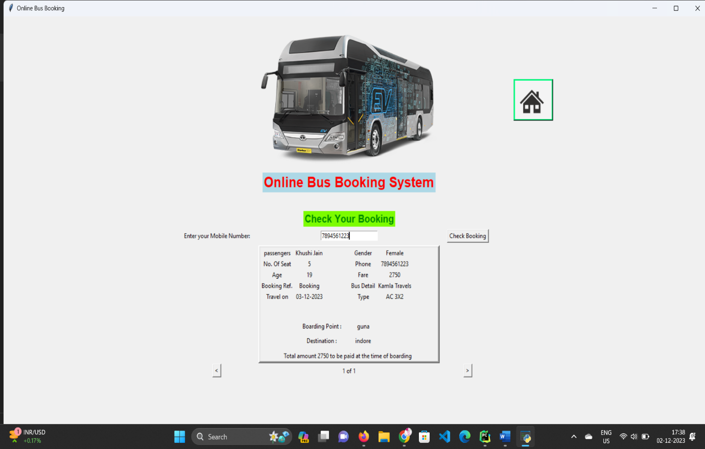

# displays the ticket booked with following phone number